**I.Test Level Examples (G-mail)**

|  |  |  |
| --- | --- | --- |
| 4 | Acceptance | Completely complete the script "write a letter"  1. Log in to mail  2. Select "Write a letter"  3. Enter email in the "To" column  4. By inserting the word "test" into the "Subject" column  5. Click "Submit"  6. Check for a letter in the "Sent". |
| 3 | System | Opening and working mail in different browsers |
| 2 | Integration | The relationship of the module "Menu" with the module "Inbox" |
| 1 | Unit (Component) | Module "Login to the System" (login + password)  Module "Contact storage"  Module "Display of contacts" |

**II. Non-functional testing Examples**

|  |  |  |
| --- | --- | --- |
| 1 | Load | 1. The number of transactions per minute (Privat24)  2. Number of requests for the schedule (railway)  3. The number of samples analyzed per hour |
| 2 | Endurance | 1. Continuous 24/7 air supply in a certain volume (ventilation of the lungs)  2. Maintaining a certain level of current on all equipment during a shift (automated control) |
| 3 | Stress | 1. Sending to print documents 1 pc., 5, 19 (maximum 20)  2. Ticketing during daytime, then during rush hour (E-tiket) |
| 4 | Stability | 1. Cyrillic input is not provided (parking system)  2. Conflict with incorrect data entry (system hangs) |
| 5 | Performance | 1. Transaction speed (limit 1 minute) (Privat24)  2. Card balance update rate upon purchase (Privat24) |
| 6 | Usability | 1. Ability to select a language  2. Warning of a possible error (check the selected language) (example: entering a password in 1C). |
| 7 | Maintainability | 1. Splitting the module into submodules (small volume is easier to check and repair than large)  2. Do not use rare resources (programming language, testing only on certain systems) |
| 8 | Efficiency | 1. Remove extra test cases overlapping each other  2. ??? |
| 9 | Volume | 1. Display speed with increasing data (loading the address book when expanding the contacts database)  2. |
| 10 | Security | 1. Blocking the card after 3 times incorrect input of a PIN  2. Confirmation via the phone when running the application on another device (Privat24) |
| 11 | Portability | 1. When installing a new version of Windows, the application works (example: Correl)  2. Ability to resave document in new format (doc→docx) |
| 12 | Internationalization | 1. Writing from right to left (Arab countries)  2. Use points and spaces to separate the amount (US) (for example: 23 000.55 $) |
| 13 | Recovery | 1. The data of the results of the analysis do not tereyayutsya at power off (biochemical analyzer)  2. Saving the performed actions at the interruption stage (sudden reboot of the system) (for example: storing the goods in the cart and card balance when payment is interrupted) |
| 14 | Compatibility | 1. On the example of the game. The video card does not support animation, it is possible to choose the display quality  2. Correct display and work in different browsers |
| 15 | Baseline | 1. In the requirements for the login to specify which characters you can enter, and which are not  2. In the "card payment" requirements, the types of cards that can be paid must be re-read |
| 16 | Documentation | ??? Check all documentation (requirements, specifications for design) |
| 17 | Acceptance |  |

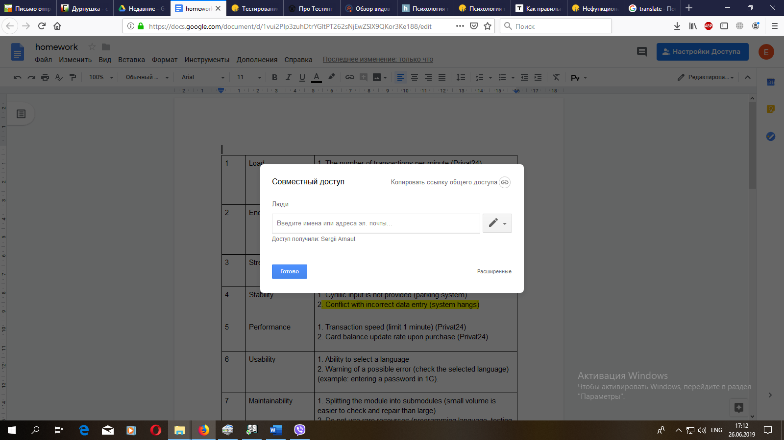Модуль?